Aim:

Design a LCD interface programmable digital data display system .

Circuit Diagram:

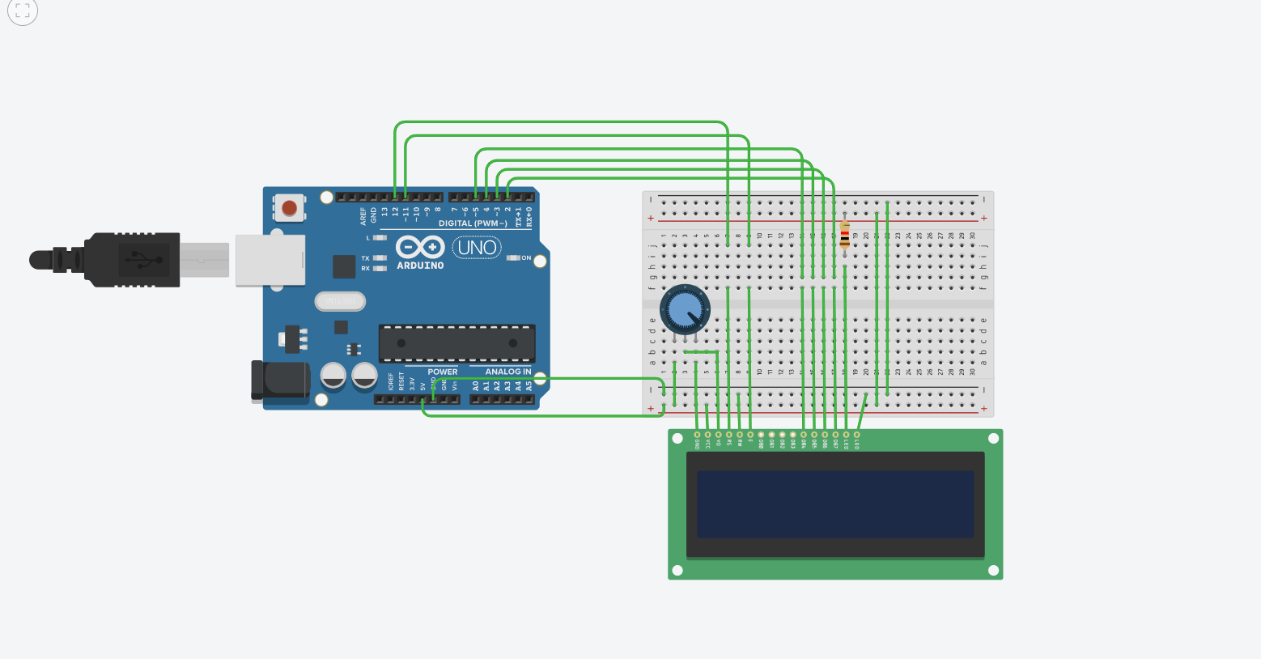

Theory :

LED is a light emmiting diode that gives light as a output. It is a semiconductor. They require very less power to get lighted and work very efficiently.

Arduino:
An Arduino UNO is a device that is equipped with digital and analog input/output slots. It has 14 Input/Output slots, 5 Analog slots and can work between 7 to 20 volts.It has 3 ground pins. It works when user inputs code into arduino.

Concept Used :

- We have used the concept of LCD(liquid crystal display).
- A register select (RS) pin that controls where in the LCD's memory you're writing data to. You can select either the data register, which holds what goes on the screen, or an instruction register, which is where the LCD's controller looks for instructions on what to do next.
- A Read/Write (R/W) pin that selects reading mode or writing mode
- An Enable pin that enables writing to the registers
- 8 data pins (D0 -D7). The states of these pins (high or low) are the bits that you're writing to a register when you write, or the values you're reading when you read.
- There's also a display constrast pin (Vo), power supply pins (+5V and Gnd) and LED Backlight pins that you can use to power the LCD, control the display contrast, and turn on and off the LED backlight, respectively
- We have used the potentiometer for variable resistance.
- Learning and observation:
- The Liquid Crystal library works with all LCD displays that are compatible with the driver.
- Potentiometer keeps voltage difference constant.
- A digital data display of hello world can be seen when you turn on the circuit.
- A in-built library #include <LiquidCrystal.h> is used to reduce the code which already contain the details of connections.

Observation :
LCD displays what is written in programme .
Learning Outcomes:

- Learned about the different components in an Arduino.
- Learned how to connect the wires in an Arduino, and breadboard and writing the program.
- Learned how a Ultrasonic Sensor works and its connections with Arduino using breadboard.

Problems :

- Connections of LED may not be connected properly.
- LED's may not be working.
- Code may be wrong
- Arduino is not working.

Troubleshooting:

- All connections should be checked properly.
- Arduino should be working.
- LED's that are in working conditions should be used.
- Right code must be used.

Precaution:

- Don't plug in an LED without a current limiting resistor.
- Don't supply more than 9V unless proper knowledge.
- Check all the connections.

